**Phase 1 – Requirement Gathering & Analysis**

**Step 1: Stakeholder Meetings**

* **With Bookstore Owner**:
  + Discuss business vision (online expansion, efficiency goals).
  + Identify priorities (reduce stock errors, improve customer communication).
* **With Staff**:
  + Walk through daily workflows (receiving orders, updating stock, managing suppliers).
  + Note manual bottlenecks and repetitive tasks.
* **With Customers (if possible)**:
  + Gather expectations (quick updates, easy ordering, payment convenience).

**Step 2: Pain Point Identification**

* **Inventory Issues**: Stock mismatches, no real-time updates.
* **Order Issues**: Manual tracking delays, accidental out-of-stock sales.
* **Communication Issues**: No automatic notifications (orders, deliveries).
* **Reporting Issues**: No visibility into sales, low-stock, or customer history.

**Step 3: Documentation**

* Prepare a **Requirement Specification Document** with:
  + **Functional Requirements** (e.g., Auto-reduce stock, send order confirmation).
  + **Non-Functional Requirements** (e.g., Scalability for e-commerce, security).
  + **Use Cases/User Stories** (e.g., “As a Sales Staff, I want to search books by genre so I can quickly place customer orders.”).
  + **Process Flow Diagrams** (inventory cycle, order lifecycle).

**Step 4: Industry & Competitor Study**

* Research **existing CRM/bookstore apps** (Amazon Seller tools, Shopify integrations, etc.) for inspiration.
* Identify **features to borrow** (low-stock alerts, dashboards) and **gaps to avoid**.

**Phase 2 – Organization Setup**

**Step 1: Environment Setup**

* 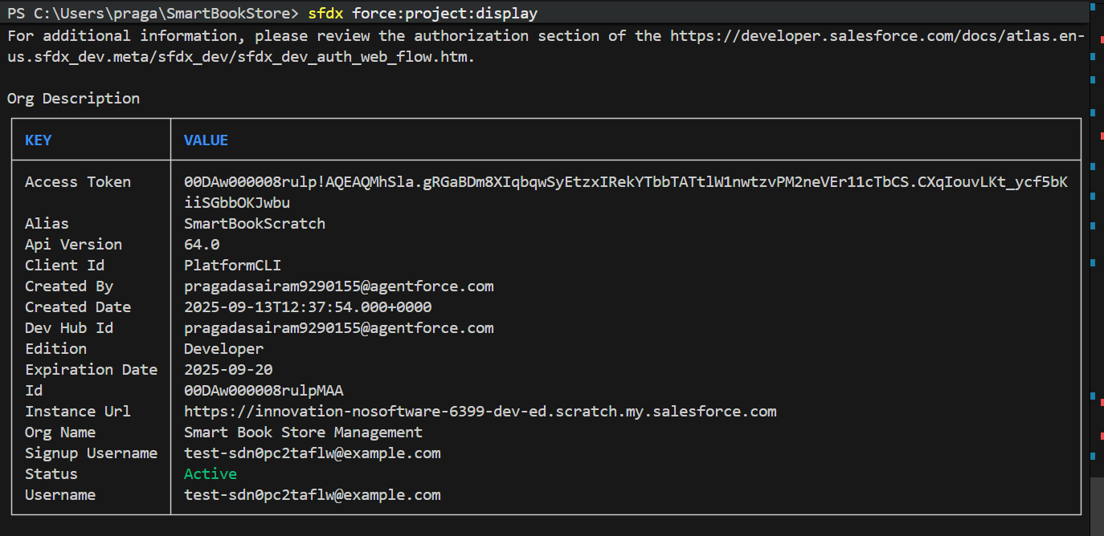**Create Salesforce Developer Org** for configuration & coding.
* 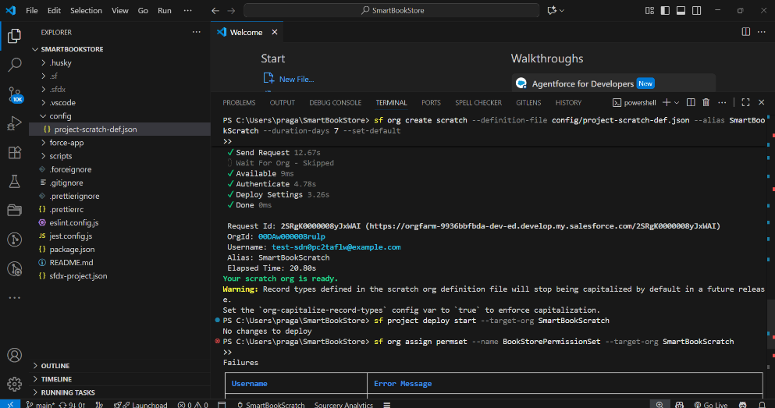**Set up Scratch orgs** (for testing before production release).

**Step 2: User Management**

* **Users to Create**:
  + *Manager* – oversees entire system.
  + *Sales Staff* – handles orders & customers.
  + *Support Staff* – manages customer queries, updates.
* **Roles Hierarchy**:
  + Manager → Sales Staff → Support Staff.
  + Ensure higher roles have visibility into lower-level data.
* **Profiles/Permission Sets**:
  + Define profiles with baseline access (e.g., Staff can read Books but can’t edit stock).
  + Create permission sets for special tasks (e.g., stock editing, report creation).

**Step 3: Security Model**

* **Organization-Wide Defaults (OWD):**
  + *Orders*: Private (only owner can see unless shared).
  + *Books*: Read-only for staff, full access for manager.
  + *Customers*: Controlled by role hierarchy.
* **Sharing Rules:**
  + Allow Managers to access all Orders and Customers.
  + Allow Sales Staff to share their Orders with Support Staff when needed.
* **Login Security:**
  + Configure *Login IP Ranges* for internal access.
  + Enable *Two-Factor Authentication* for Managers.